**KPI metrics, or Key Performance Indicator metrics**



KPI metrics, or Key Performance Indicator metrics, are quantifiable measures used to assess the performance or progress of specific business objectives or goals. They serve as benchmarks for evaluating the success of strategic initiatives and guiding decision-making processes. Here are some key characteristics of good KPI metrics:

1. **Alignment with Long-Term Goals**: KPI metrics should provide statistical evidence of progress towards long-term strategic goals. They should directly relate to the organization's mission, vision, and overarching objectives.
2. **Decision Support**: Effective KPIs measure key business objectives, providing valuable insights that help stakeholders make informed decisions. They offer actionable information that drives improvements and optimizations.
3. **Temporal Comparison**: KPI metrics enable comparison of performance over time, allowing organizations to track changes and trends. This temporal aspect is essential for assessing progress and identifying areas for improvement.
4. **Balanced Leading and Lagging Indicators**: Good KPIs strike a balance between leading and lagging indicators. Leading KPIs provide predictive insights into future performance, while lagging KPIs track historical outcomes. A mix of both types helps organizations understand what drives success and what has already been achieved.

Examples of common KPI metrics include:

* **Revenue KPIs**: Measure the total revenue generated by the company over a specific period.
* **Sales KPIs**: Assess the performance of sales activities, such as monthly sales growth or sales conversion rates.
* **Strategic KPIs**: Evaluate the effectiveness of strategic initiatives and plans implemented by the organization.
* **Profit Margin**: Calculate the percentage of profit earned per sale after deducting expenses.
* **Customer Service KPIs**: Gauge the quality of customer service and its impact on customer satisfaction and retention.

To identify the most relevant KPIs for your business, consider questions such as:

* What are your ultimate business objectives?
* Why do these objectives matter to your organization?
* How do you plan to achieve these objectives?
* How will you measure progress towards these goals?
* How frequently will you review and adjust your KPIs?

For instance, if the goal is to increase revenue by 20% by the end of the year, relevant KPIs may include monthly sales growth, customer acquisition cost, customer retention rate, and upselling success rate.

In summary, KPI metrics play a crucial role in measuring and monitoring business performance, driving strategic decisions, and achieving organizational objectives.

**What Are Metrics?**



Metrics are quantifiable measurements used to evaluate the performance of specific business processes at an operational level. Unlike Key Performance Indicators (KPIs), which focus on overarching business objectives, metrics are more granular and provide insights into the efficiency and effectiveness of individual activities.

For instance, while the number of website visitors is a critical metric to track, it may not directly correlate with the overall success of the business. These types of metrics, often referred to as vanity metrics, may provide a sense of accomplishment but do not necessarily drive business outcomes.

However, metrics play a crucial role in tracking progress and facilitating informed decision-making. They are collected as part of routine business operations and can be customized to align with organizational goals and objectives.

Three significant reasons highlight the importance of metrics:

1. **Metrics** provides in-depth insights into how well particular campaigns, strategies, and activities are performing
2. **Metrics** allow you to gauge business performance against competitors
3. **Metrics** helps organizations identify the KPIs that are most important to an organization's success and how they interlink to each other

For example, Email deliverability may not be an important KPI for your business, but the number of emails that convert to customers most likely will be. Therefore, you need to analyze that metric (deliverability) to achieve the KPI (email conversion).

**Difference Between a KPI and a Metric**

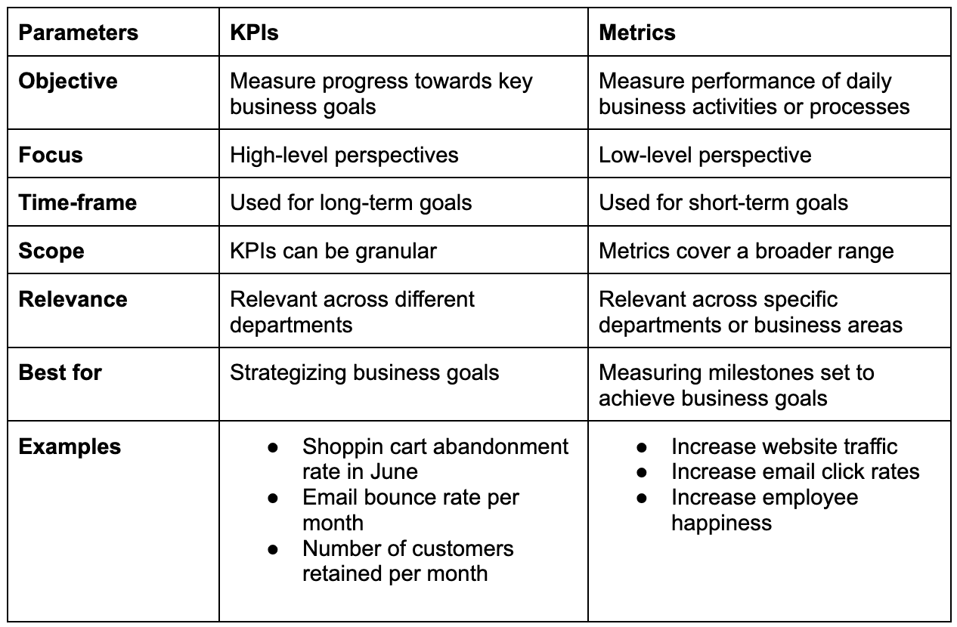

While the terms KPI (Key Performance Indicator) and metric are sometimes used interchangeably, they hold distinct meanings and purposes within business management.

1. **Definition and Purpose:**
   * Metrics are units of measurement used to evaluate various aspects of business performance. They provide data points that can be analyzed to gain insights into operations.
   * KPIs, on the other hand, are specific metrics with predefined goals or targets set for a particular period. They serve as indicators of progress towards strategic objectives.
2. **Goals and Data Points:**
   * KPIs represent business outcomes or objectives that departments or teams aim to achieve. They are typically tied to specific targets or goals.
   * Metrics, on the other hand, are individual data points that contribute to the calculation of KPIs. They provide detailed information about different aspects of business operations.
3. **Timeframe:**
   * KPIs are linked to important objectives and measure progress over a defined timeframe. They focus on achieving specific goals within a set period.
   * Metrics are not necessarily bound to significant goals or timeframes. They provide ongoing data that can be monitored continuously.
4. **Level of Focus:**
   * KPIs are focused indicators that provide a high-level perspective on business performance. They align with key objectives and guide strategic decision-making.
   * Metrics, in contrast, offer a more granular view of business processes and performance. They address specific areas or problems within the organization.
5. **Superiority:**
   * While both KPIs and metrics are essential for performance measurement, KPIs hold greater significance in terms of strategic alignment and goal achievement.
   * KPIs represent the main objectives and priorities of the organization, while metrics provide supporting data to track progress towards those objectives.

In summary, while every KPI is a metric, not every metric is a KPI. KPIs are specific, goal-oriented metrics that drive strategic decision-making and align with key business objectives. Metrics, on the other hand, provide detailed insights into various aspects of business operations and contribute to the calculation of KPIs.

**KPIs vs Metrics Examples**

Let's delve into an example to illustrate how KPIs and metrics are utilized to measure specific objectives, such as increasing sales by 25% in 12 weeks.

**KPI: Sales Growth**

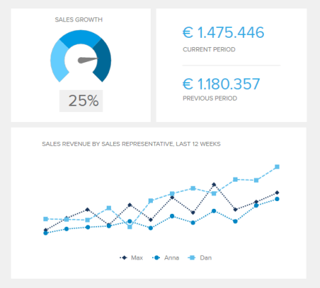

Imagine you aim to achieve a sales growth target, and you need to monitor the progress towards this goal. Your KPI, in this case, is the overall sales growth percentage over time.

**Metric: Lead to Conversion Ratio**

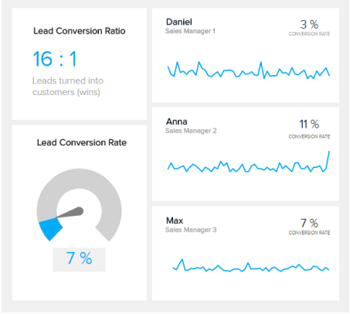

One of the metrics you can use to analyze progress towards the sales growth KPI is the lead-to-conversion ratio. This metric measures the number of leads that successfully convert into paying customers, directly contributing to sales growth.

By tracking the lead-to-conversion ratio, you gain insights into the effectiveness of your sales efforts in turning leads into customers. Additionally, you can assess individual sales representatives' performance by examining their conversion rates.

**Other Metrics:**

* Lead-to-opportunity ratio
* Net profit margin
* Monthly sales

These additional metrics provide further granularity and allow you to analyze various aspects of your sales process. For example, the lead-to-opportunity ratio helps evaluate the quality of leads generated, while net profit margin provides insights into the profitability of sales.

By leveraging a combination of KPIs and metrics, you gain a comprehensive understanding of your progress towards achieving the overarching sales growth goal. KPIs offer a high-level view of performance, while metrics provide detailed insights and actionable data to drive improvements and achieve objectives.

Top of Form